When: Enter Time

Texting and DUI/SWI Simulator
(888) 436-3394
www.ar rivealivetour.com

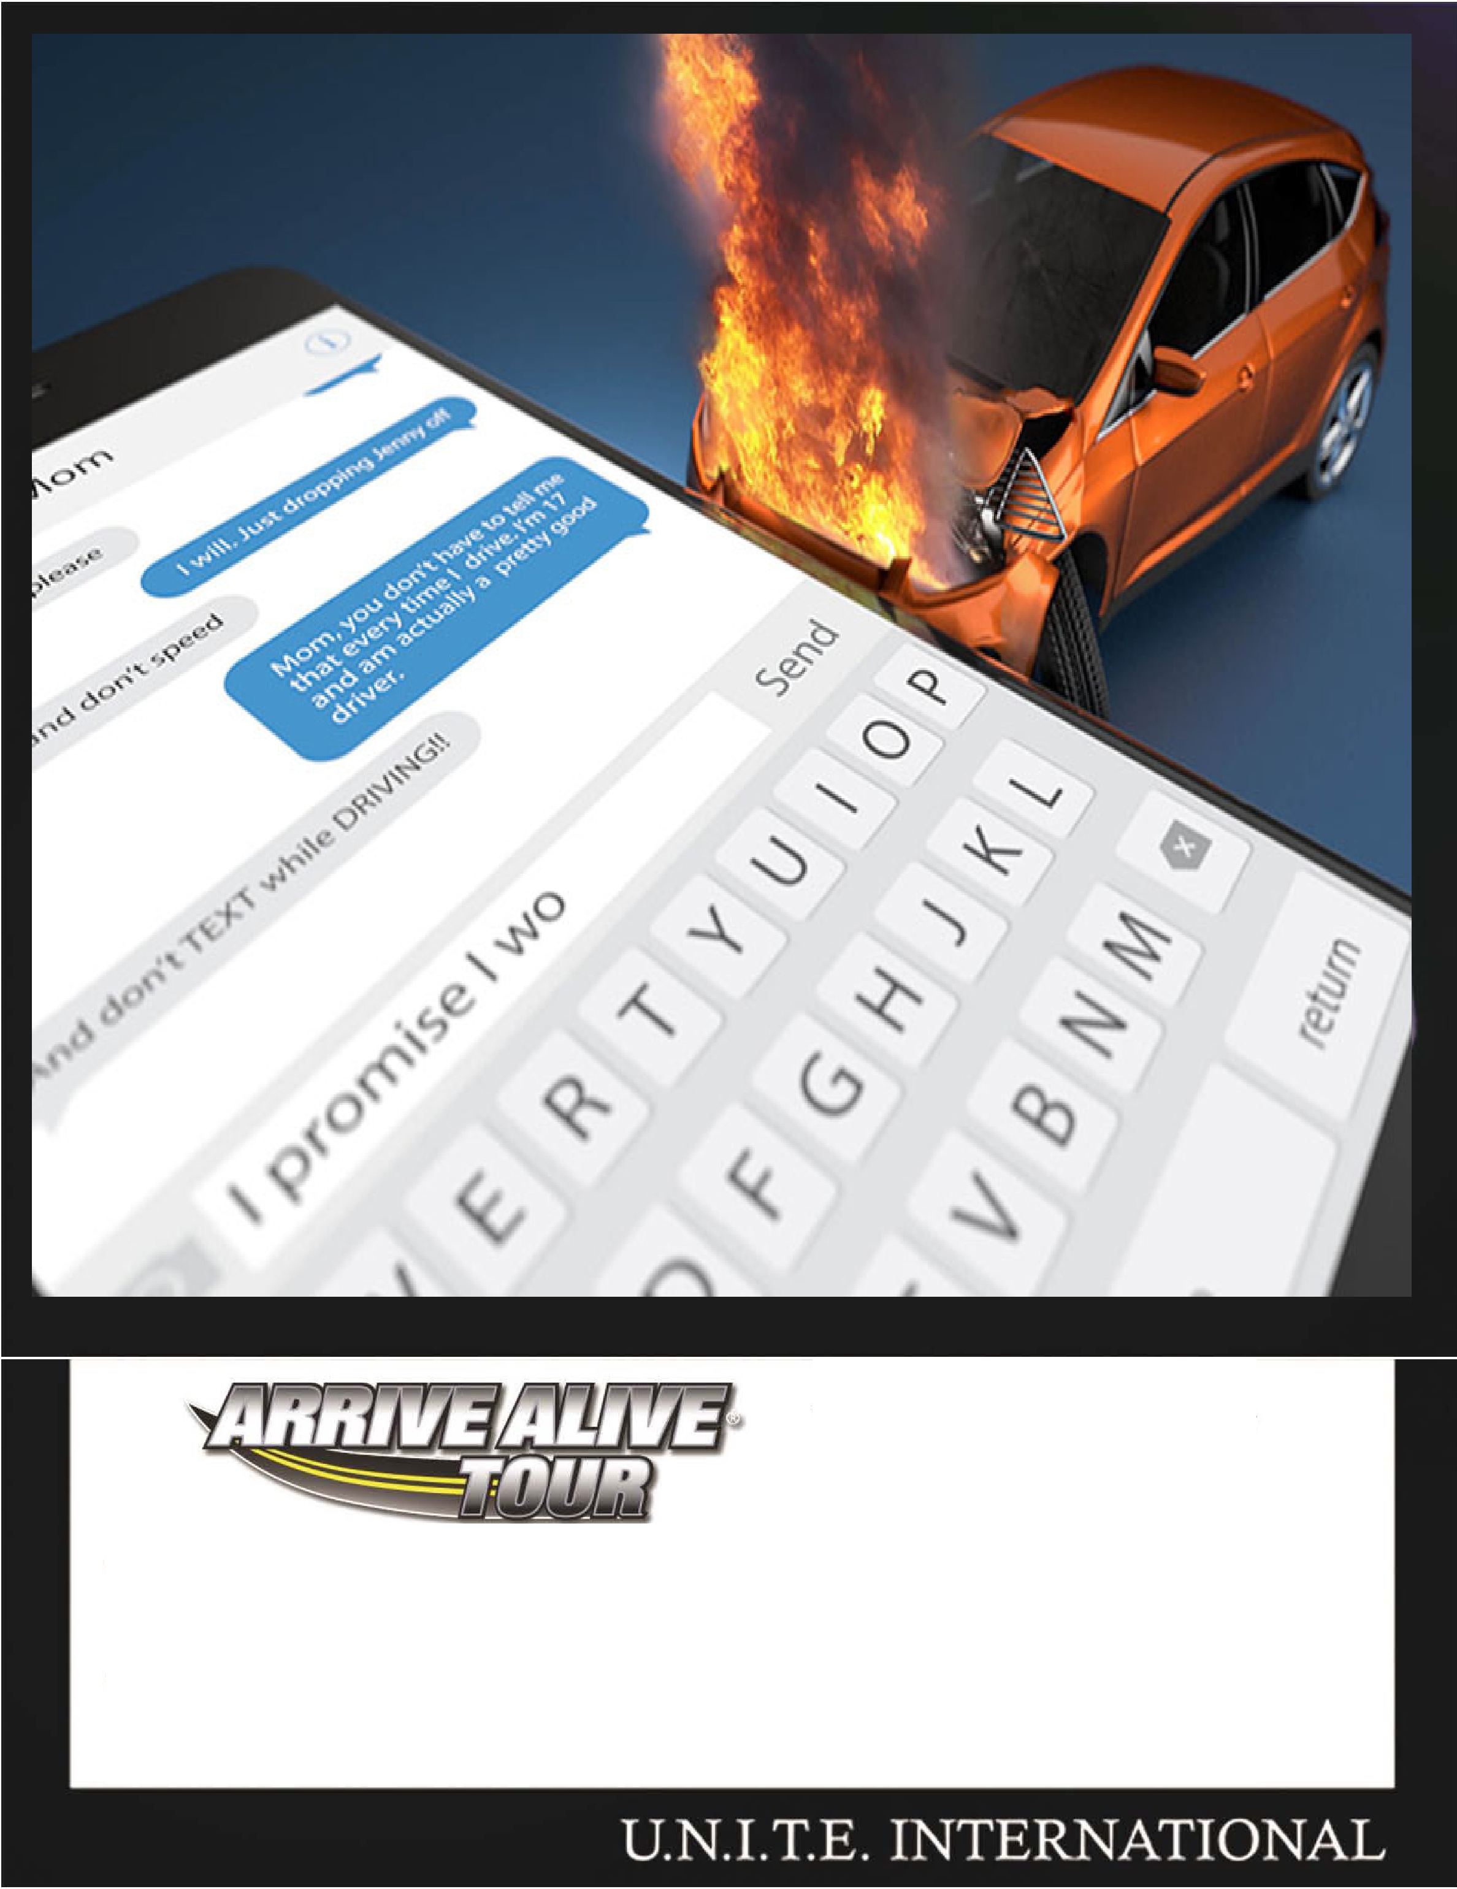
Where: Enter Location

